CHAPTER

5

LITHOGRAPHY

AND ETCHING

1. INTRODUCTION
In a more complex circuit more masking levels are usually necessary. However, in each case in order to carry out batch processing the pattern for each individual circuit must be repeated over an array that is large enough to cover the whole wafer. We can identify several requirements that must be met by the technique used for forming the patterns.
- It must be suitable for forming patterns in different types of surface film. In our example the first pattern was formed in SiO₂ while the second was formed in aluminium.
- It is necessary to be able to "align" each pattern level accurately with the preceding one.
- The dimensional accuracy of each individual pattern must be sufficient to ensure proper alignment between the levels.
- The chip size or repeater distance must be accurately maintained between different levels since any error would accumulate across the array and lead to misregistration on some circuits within the array.
The technique generally used in the semiconductor industry for all pattern formation is known as lithography. The most common one uses ultraviolet light and is called photolithography. Other types are electron beam and X-ray lithography , but these are yet in common use. In order to illustrate how it operates, and show the first level pattern in the SiO₂ ( the operating for the p+ diffusion) would be produced. As we proceed it will become apparent how the above requirements are satisfied.
The process has similarities with conventional photography in that there is a light-sensitive film, or emulsion, a controlled exposure to an image and a development. A "safe-light" environment in which to carry out the processing is also necessary to prevent over-exposure and loss of image Fig.1. shows the various stages in the process.
- The silicon wafer is first oxidized
- The wafer is coated with a U.V. light-sensitive film
- A glass "mask" containing the pattern for the appropriate level is brought into contact with the wafer. The mask can be used directly with its emulsion coating (an emulsion mask) or, if the pattern is transferred to a metal film, as a metal mask. The metal usually used is chromium.
- The whole is then exposed for the correct exposure time to a collimated beam of UV light, following which the mask if removed.
- The resist film on the wafer is then developed. At this stage the mask pattern has been reproduced in the photoresist, but as a negative
- A suitable etch has to be used which will remove SiO₂ but will not attack the photoresist film or the underlying silicon significantly. When the SiO₂ in the uncovered areas and the photoresist has been removed, we have achieved the final objective of producing a pattern of "holes" in the SiO₂ for the subsequent p-diffusion.
Now suppose we wished to produce the level 2 pattern in aluminum. The process would be generally similar but with the following modifications:
- The underlying film would be aluminum rather than SiO₂
- The SiO₂ selective etch used in step (f) would be replaced by an aluminum selective etch.
- A different mask would be used with the second level patterns on it.
- The second pattern would have to be aligned with the first so that the aluminum contact lies in the correct position over the p-region window.

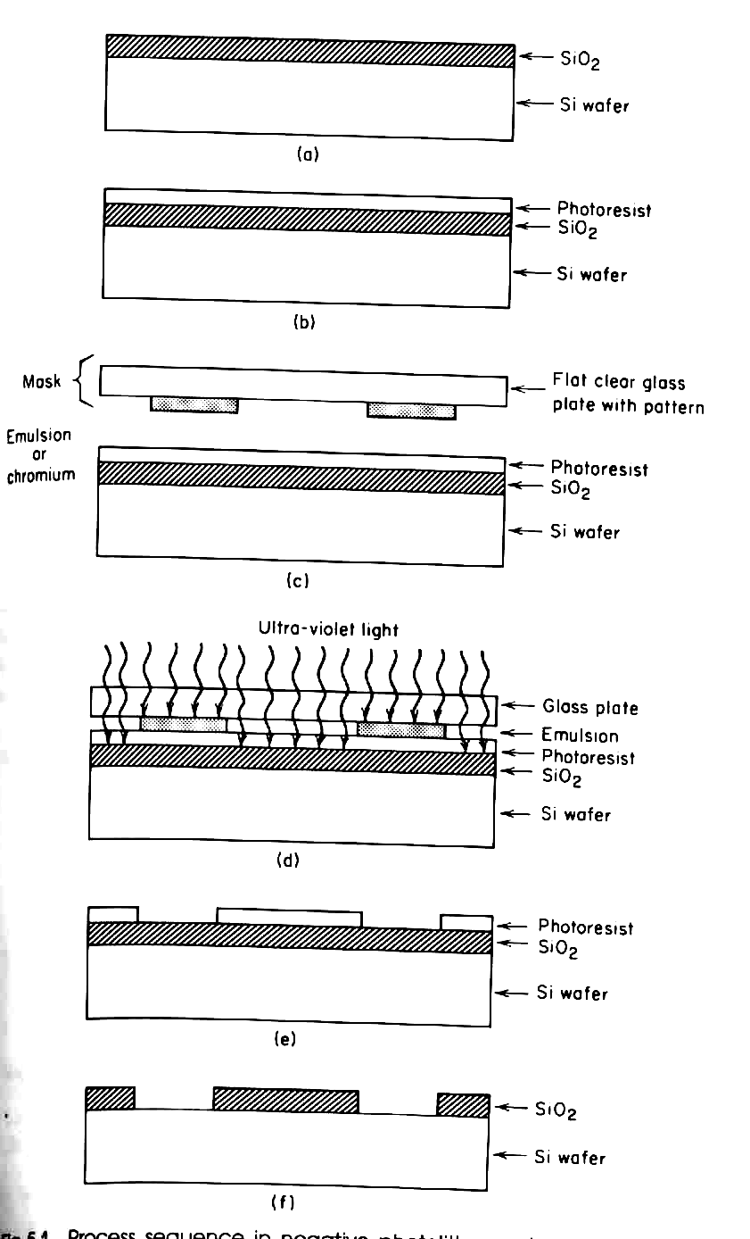
Fig.1. Process sequence in negative photolithography: a) growth of SiO2 film, b) coating with photoresist, c) mask placed in proximity, d) mask aligned and brought into contact, e) photoresist developed, f) oxide etch and photoresist removed.
2. PHOTORESIST TYPES
Photoresists are supplied in the form of a liquid and consist of some UV sensitive substances in a solvent base. If a comparison is made between the mask and substrate in (Fig.1-c, and e) will be observed that the pattern produced in the photoresist is the inverse or negative of that on the mask. For this reason those resists that are not removed on exposure to UV light and development are known as negative resist. Other types of resist which are positive working are removed on exposure and development. A comparison between positive and negative resists is made in Fig.2, where the same final pattern in SiO₂ is produced by the alternative techniques.
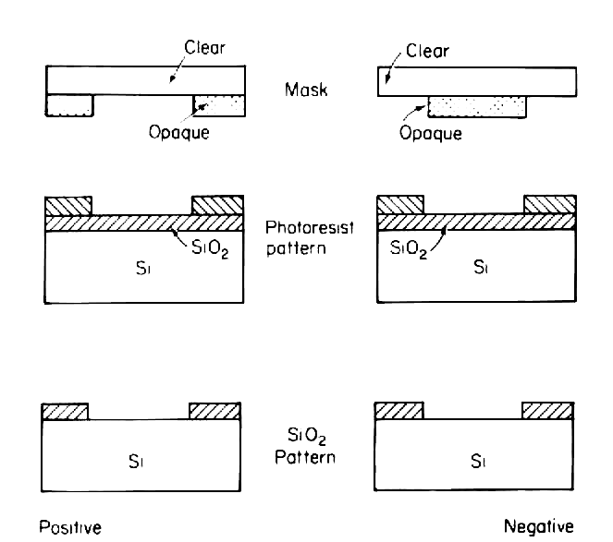
Fig.2. Positive and negative resists
Negative resists consist of a base of synthetic compounds containing a few percent of a light-sensitive agent which facilitates the formation of cross linkages between base molecules. This cross linking inhibits its dissolution so that exposed areas remain while unexposed areas are removed in an appropriate solvent.
Positive resist have a quite different chemistry, a light-sensitive compound in this case inhibiting dissolution unless the action of light has previously broken up the compound. In this case exposed areas are removed and unexposed areas remain.
If photoresist films are underexposed, there is a tendency for the pattern formation to be incomplete, and in the extreme a total loss of pattern can occur. With positive resist the film remains intact while for a negative resist the whole is removed.
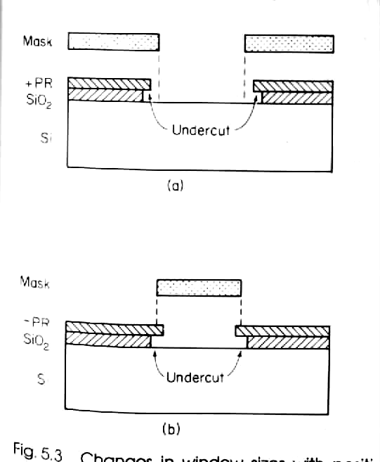
Fig.3 Changes in window sizes with positive and negative resists a) positive resist, b) negative resist.
If the film is overexposed, then windows opened in positive photoresist are slightly larger than the mask dimensions. This is because scattered light penetrates under the mask edges and exposes a small region of film not directly irradiated by the light source. Subsequent etching of the underlying SiO₂ film accentuates this enlargement, as shown in Fig.3-a.
With negative resists the windows tend to be smaller than the mask dimension as illustrated in Fig.3-b but this is partly compensated for during the etching of the SiO₂.

3. FILM THICKNESS
One of the important functions of the photoresist film is to protect underlying films of varying types (e.g. SiO₂, aluminum, polysilicon, silicon nitride). Thus it has to be of sufficient thickness to provide an effective barrier to the various etches to be used. Also, in the case of selective ion implantation it has to prevent ions from reaching the underlying silicon.
This sets a lower limit on film thickness. An upper limit is set by the need for good definition in the pattern as shown in Fig.4. It is unlikely that sidewalls will be precisely vertical following development and clearly the thicker the film is, the greater will be the effect of any uncertainty as a percentage of the nominal window dimension. Thus the technique for coating wafer surfaces with photoresist over the thickness.
The way in which thin, uniform films are obtained is illustrated in Fig.5. Drops of liquid photoresist are introduced onto the slice held by a vacuum chuck which can be set to rotate accurately at some predetermined speed. The slice is then spun, centrifugal forces spreading the liquid outwards, any excess being thrown clear of the periphery. After a certain time the thickness stabilizes at a value dependent upon the rotational speed.
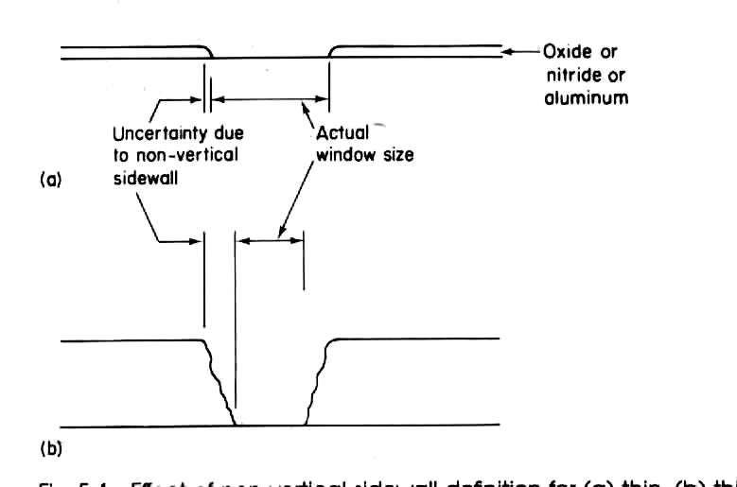
Fig.4. Effect of non-vertical sidewall definition for: a) thin, b) thick resist films.
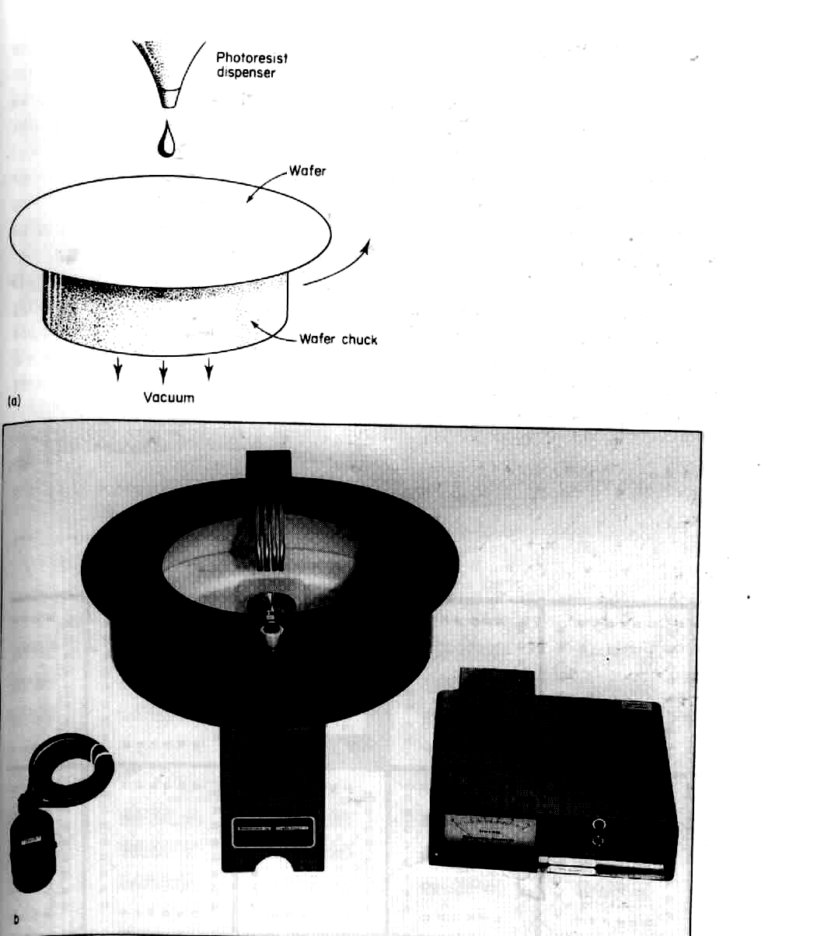
Fig.5 Photoresist film formation: a) coating with photoresist, b) commercial photoresist spinner.
The slice is then removed and baked in order to drive of the solvent and form a solid film which is thin and uniform over most of the slice. Some increase in thickness inevitably occurs at the edge of the slice due to surface tension in the liquid. This it may be necessary to discard later some circuits very close to the edge. Fig.5 also illustrates a commercial one-head spinner with accurate speed control, with very high acceleration and deceleration at the start of the spin cycle.

4. MASKS AND MASK MAKING
The prerequisite in the photolithographic process is a mask set each containing a uniformly repeated pattern appropriate to the particular processing level for which it is intended. A photograph of a typical mask is shown in Fig.6 with an enlarged view of some of the patterns also illustrated. The mask consists of an ultra-flat square glass plate, typically a few mm in thickness with one face covered with the pattern. It is, of course, this face that always has to be brought into contact with the coated slice during exposure.
The opaque regions are usually chromium and the patterns are formed by a similar photolithographic technique to the one discussed earlier. However, the additional complication present in mask making is that the pattern images have to be repeated in precise steps.
The way in which masks are produced is illustrated in Fig. 7. The integrated circuit designer has decided upon the number of masks needed for the complete process and has produced carefully dimensioned sketches of each mask. When the complexity of the integrated circuit is not very high the pattern is cut, say at a few hundred times actual size in double-skinned Mylar sheet. Mylar is a special plastic film which is dimensionally very stable.
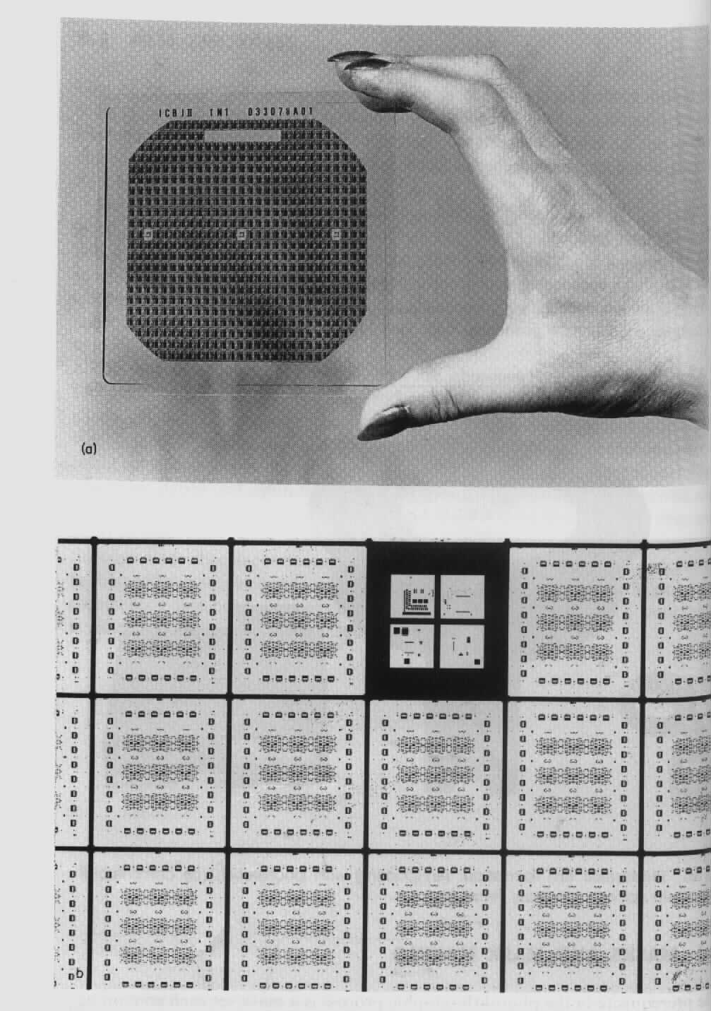
Fig.6 Mask plate with enlarged view of one circuit: a) mask photograph, b) enlarged pattern of above mask.
One skin is clear and the other is usually red and therefore photographically opaque. The pattern is cut in the red film and peeled away where clear are desired. The cutting is usually carried out on a precision table where the x and y positions of the cutter can be very accurately controlled. Only one pattern of the array is cut and the resulting sheet at this stage is called the initial artwork. The pattern is reduced by a factor of 10 or more using a reduction camera and the result is an intermediate photographic plate containing one pattern 10 times larger than finally required.
The final reduction is combined with precise stepping of the pattern in a piece of apparatus known as a step and repeat camera. This is illustrated schematically in Fig.7.
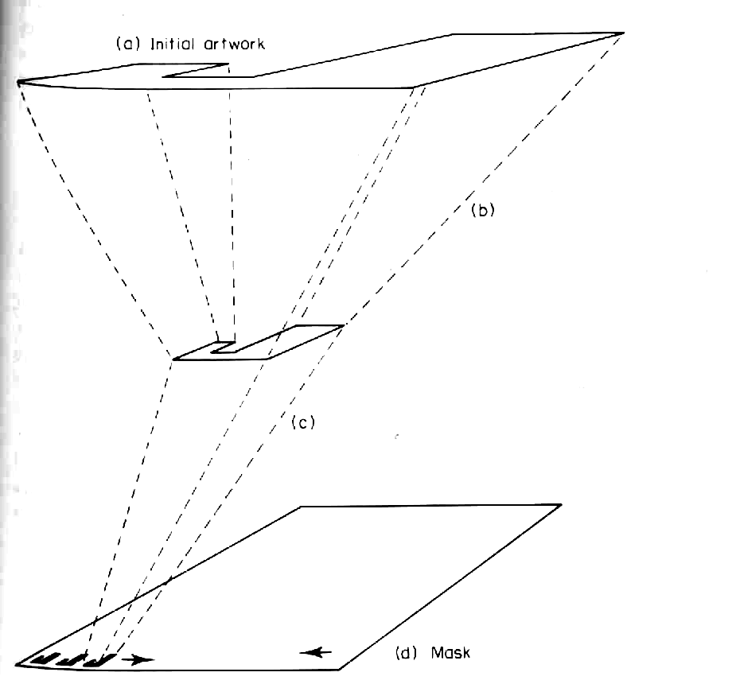
Fig. 7. Two-stage mask making procedure: a) initial artwork, b) first reduction (~ x10-40), c) step and repeat (~x10), d) mask
An alternative mask-making technique which is increasingly used, particularly for high-density circuits, for the designer to "digitize" the required patterns on the screen of a special purpose computer. The patterns are then stored on tapes which are used to drive a mask-making machine directly. An obvious advantages of this approach is that standard designs may be stored and, if necessary, modified at will without having to write off any earlier effort and start afresh each time.
Also it enables the designer to check his design with great accuracy since the facility to zoom in on any portion of the overall circuit and to view several levels simultaneously is readily available on such machines. Because of the emergence of powerful low cost workstations in recent years, the use of special purpose machines is progressively taking over, both for fully customized VLSI design, and for such semi-custom approaches as gate arrays and standard cell libraries.

5. MASK ALIGNMENT
As mentioned, when more than one layer is to be used, each mask has to be precisely aligned with the previous layers. This is usually done by means of registration marks included on each mask. These masks are etched or pattered onto the silicon wafer along with the required pattern, for each mask used. The corresponding registration marks on the next mask to be used are then aligned under a microscope by means of a moveable stage. When alignment is correct the mask and wafer are brought into contact and the wafer exposed to UV light.
An alternative system, the project mask aligner, does not bring the mask and wafer into contact but projects one pattern at a time onto the wafer. This reduces damage to the mask and photoresist film but places stringent demands on lens quality and vibration control.

6. ELECTRON BEAM LITHOGRAPHY
Conventional photolithography using deep UV light (i.e. short wavelength) is at best limited to line definitions of just below 1 µm. A way of overcoming this problem is to use even shorter wavelength radiation such as X-rays or electron beams. Although the potential of X-ray lithography is being evaluated it is not yet in common use and will not be discussed further. Electron beam lithography on the other hand has matured into a practical technology widely used by the specialist laboratories. The basis of the technique is to utilize the short wavelength of an energetic electron beam. For example, a 100 keV electron has a wavelength of 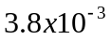 nm and in practice the limit of line definition is related to the electron beam optics rather than the wavelength as it is in optical lithography.
An electron beam lithography facility is essentially a modified scanning electron microscope. The electron beam is focused and can be deflected in two orthogonal directions as is shown in Fig.8. The desired pattern is written directly on to the chip by exposing the photoresist to the electron beam. To achieve this the beam is directed to a specific location and turned on. Automatic computer control moves the spot to scan out the desired pattern for exposure.

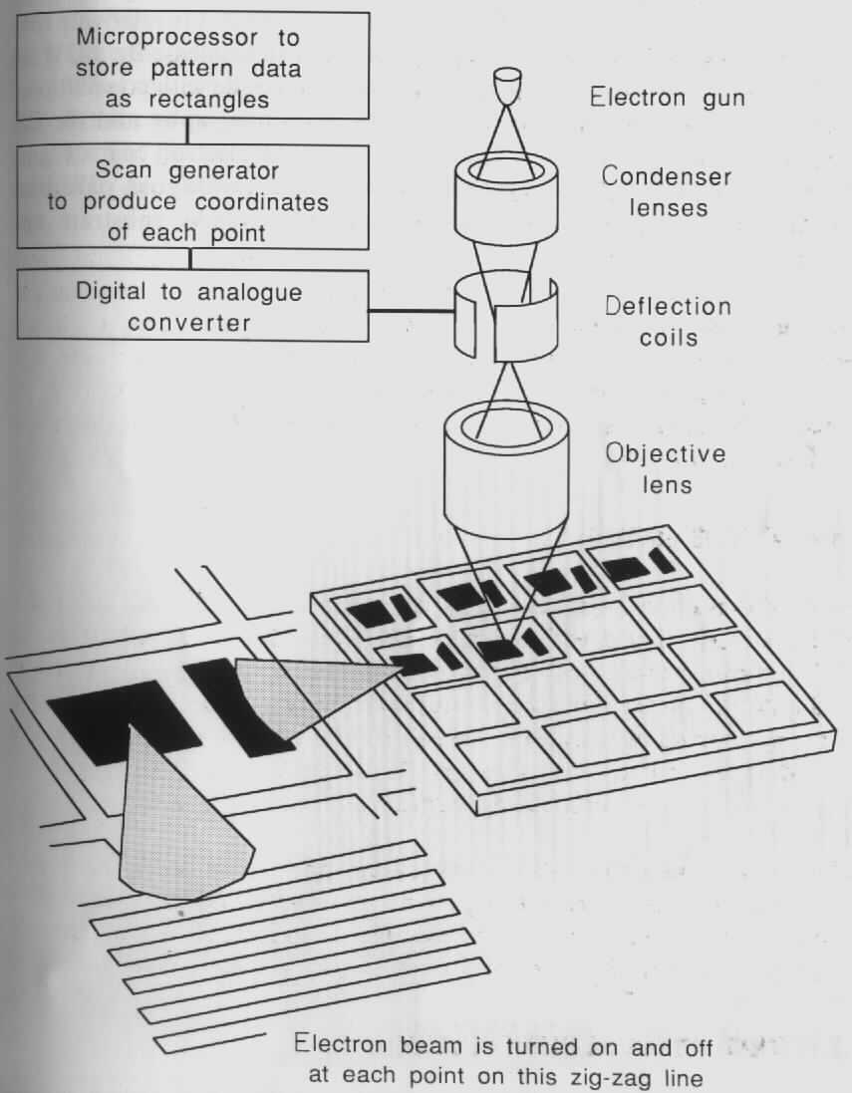
Fig.8. Illustrating an electron beam lithography facility. Note the resemblance to a conventional scanning electron microscope.

7. CHEMICAL ETCHING
In the preceding section chemical etching of polishing was introduced as a means of removing surface damage resulting from the sawing of the wafers. Surface etching has however a much wider use in microtechnology and this will now be discussed. One important use of etching is in the successive diffusion (or ion implantation ) stages in the making of an IC. Here it is necessary to cut diffusion windows in the protective surface oxides, to remove oxides completely or to cut windows for metallization purposes. In the case of silicon devices the oxide used is thermal silicon dioxide (SiO₂). A suitable etchant for this is hydrofluoric acid (HF) or a mixture of this acid with NH₄F. In addition to this, a number of other etches have been developed for specific applications. Etches are also needed to remove selectively, metal overlayers, the specific etches depending very much on the material that requires removal.
Returning to the crystal surface itself, a number of specialist etches have been developed over the year. Some etches produce Mesa structures, other etches are used for selectively decorating dislocation (in order to assess the perfection of the starting material) and some etches are used for decorating pn junctions. In this last category are chemicals that act differently on p-and n-type material. By selectively etching on one side of a junction, its actual position can be made visible and measured. In the second category the etch concerned acts more rapidly on the less ordered material in the vicinity of a dislocation and hence produces a small pit at the point where the dislocation reaches the surface.

7.1. Anisotropic Etches
Recently a number of etches have evolved which are capable of selectively producing a well-defined etch trough with either a V-or a U-shaped cross section. Such etches are called anisotropic etches and their successful use in device fabrication reflects the advanced state of development of silicon technology. To illustrate the principles of the technique consider one "V" groove etching technique. The basis of operation of these etches is related to the variation in packing density of the different planes in the silicon (or gallium arsenide) crystal structure. Fig.2 (CH.3) . illustrates this point and defines the three major planes (100), (110), and (111) in the crystal. From this figure it is readily seen that the atomic packing density and availably bonds decrease as we go from (111) to (100) to (110) and hence selective etches are able to remove atoms in some directions more readily than others. This principle is illustrated in Fig.9 which shows an oxide coated (100) silicon slice with two long window cuts parallel to the (110) directions. When such a sample is placed in an orientation dependent etch (H₂O), the etching proceeds to the (100) direction until the etch front hits the two (100) planes intersecting the (100) pane at the edge of the mask operating and then etching stops with the resulting "v" groove. The ratio a/L of the etch depth a to oxide opening L (a/L ~ 0.707) is fixed by the photolithographic opening L and the geometry of the crystal structure.
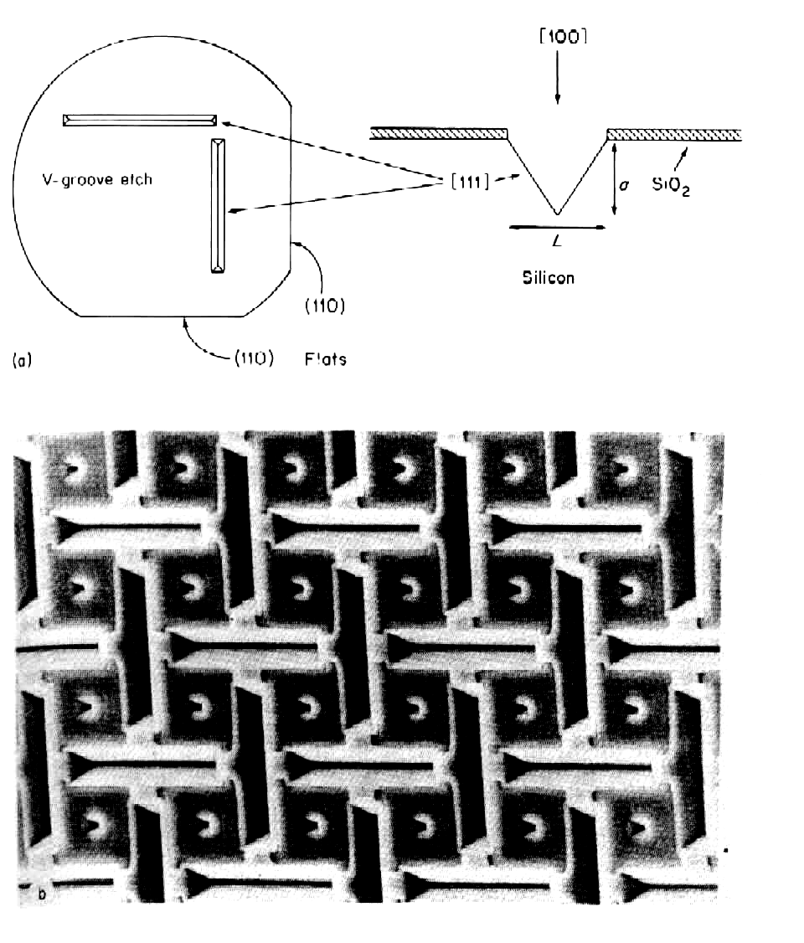
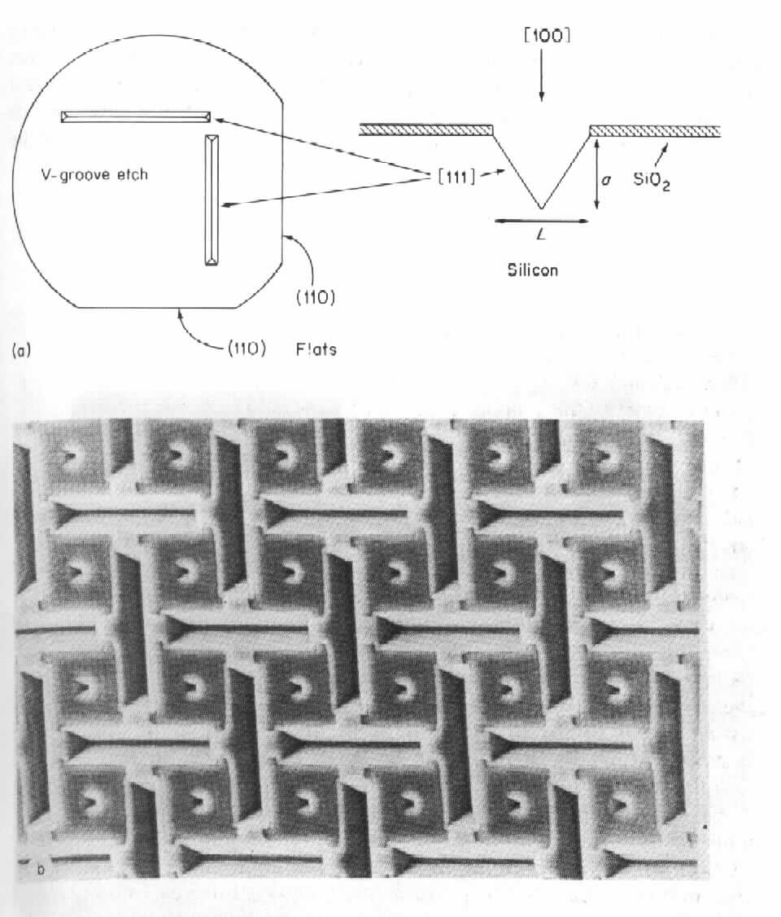
Fig.15. (a) illustrating the "V" groove anisotropic etching process b) V-grooves in silicon

7.2. Plasma Etching
The wet chemical etching processes described above have limitations when very fine patterns have to be produced. This is in essence due to the viscosity limit of the liquids needed to bring in new active radicals and the removal of the reaction products of the etch. These limitations can be overcome by plasma etching. In this case the etching is achieved by using the active species found in the plasma to attack the semiconductor surface.
The earliest plasma process used oxygen to remove photoresist. As an example of a plasma suitable for etching silicon, silicon oxide or silicon nitride the complex reactions resulting from CF₄ gas can be used. Fig.10 shows a plasma etching facility with the etching chamber.
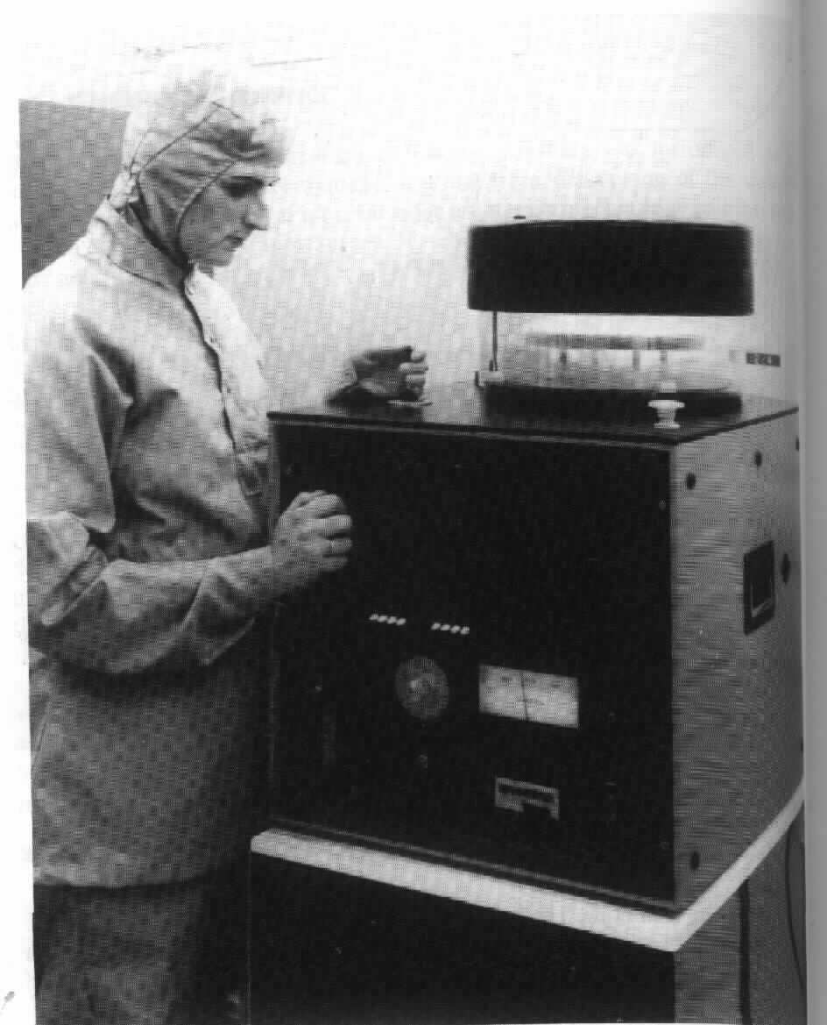
Fig.10. A plasma lab etching facility fabricated by plasma technology Ltb.

7.3. Ion Beam Etching (Ion Milling)
Ion milling is in essence the process whereby the surface of a solid is slowly eroded by using an ion beam. A collimated beam of ions with energies in the range 500 eV to 1 keV (Fig.11) are directed onto the surface of the solid. These ions can strike the near-surface atoms of the solid and in the process communicate to them sufficient energy to enable them to leave the surface, this process is called sputtering. The use of argon ions as the sputtering beam is a convenient working gas. One important advantage of this technique is that it produces nearly vertical etch pits with no problems of undercutting of the mask. This is important for future developments in submicron structures.
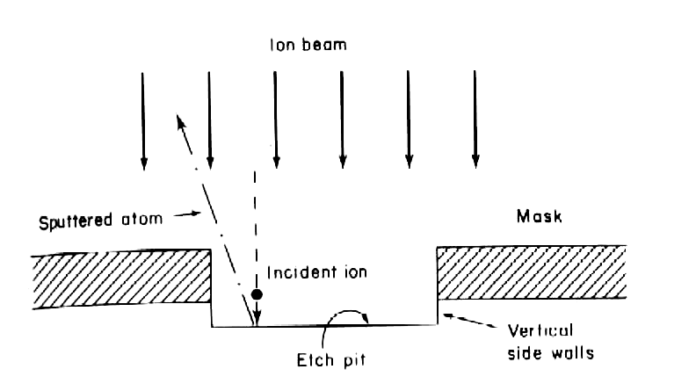
Fig.11. Illustrating the ion milling process

